# CS 255 System Design Document Template

## UML Diagrams

### UML Use Case DiagramDriverPass Use Case Diagram.pngActivity diagram CS255 2 (1).png

### UML Activity DiagramsActivity diagram CS255 1.png

### UML Sequence DiagramSequence diagram CS255 (1).png

### UML Class Diagram

## Technical Requirements

*The system should maintain an online web application with a viewable data base that is offline and online.*

*The online web application must be run through a host computer and can be acc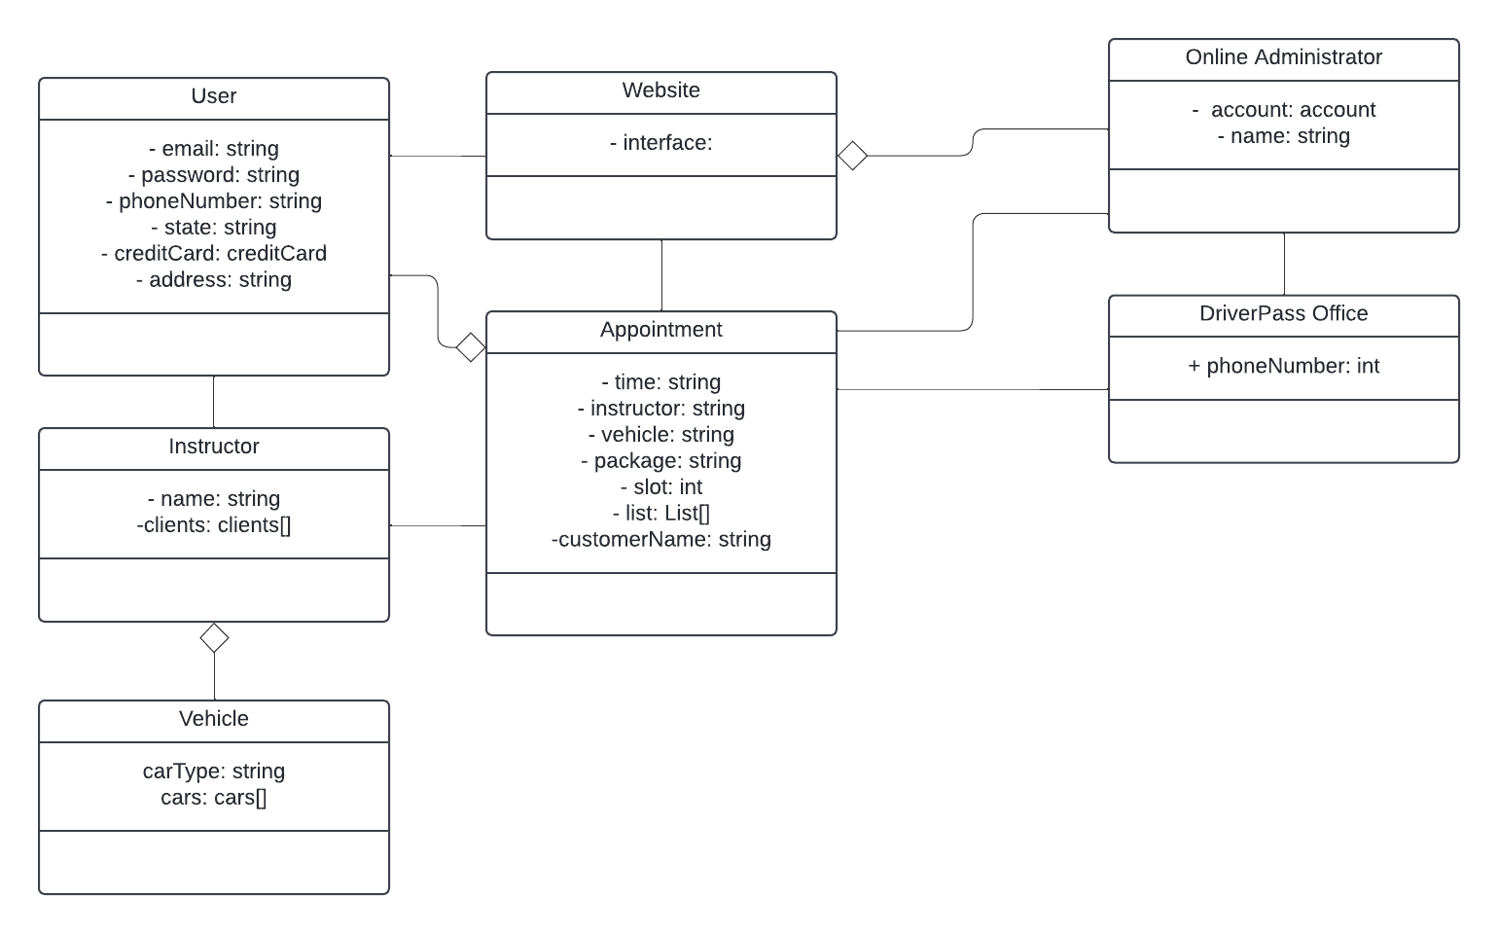essed through different operating platform browsers.*

*Internet must be available and at use during any of the online processing.*

*The system must withhold several security measurements to protect user information.*